P03 – Tab Contents

Introduction tab:

As the world population continues to increase at a rapid pace, so does the demand for food and power. But in order to produce more food and power, huge amounts of greenhouse gases are also generated as a by-product. Coal and gas power plants that produce most of the power in the world (especially in the US where they account for ~80% of the electricity production) also produce millions of tons of CO2, which makes up the highest portion of greenhouse gases in the atmosphere. Livestock around the world emit millions of tons of Methane per year which is said to be “25 times more potent than CO2” (<https://www.epa.gov/gmi/importance-methane>) according to the EPA. As every year that CO2 emissions continue to increase, global warming becomes a much more pressing issue. And as the present methods of renewable energy are plagued with problems such as inefficiency, un-reusable windmills, power storage, and general complexity and cost to setup, an alternative power source to generate electricity is urgently needed.

A viable power source we have identified in our research is nuclear power. While nuclear power is not very common presently, this is largely due to fear-mongering and historic failures of nuclear power plants, along with pro-coal and gas lobbying done by coal and gas power plant supporters. As coal and gas power plants are a massively profitable industry in the US and elsewhere, the adoption of a power production network based of nuclear power has been seriously undermined. And if major changes aren’t made to reduce CO2 emissions, global temperatures will continue to rise unabated and continue to harm both humans and the habitats of our planet.

Through our research, we identified major benefits to switch to nuclear power plants. Two of these are **higher efficiency** and more importantly, **no CO2 emissions**. As nuclear power used radioactive materials and water, the only gas it emits is steam (<https://www.cnet.com/news/how-nuclear-power-plants-could-help-solve-climate-crisis>), which is in no way harmful to the environment. And regarding the harmful radioactive waste nuclear power plants are purported to create, the little waste they do create are highly exaggerated as it is low in amount and stored in safe barrels away from human life. In order to solidify the argument on a change to nuclear power, we analyzed several data sets to learn more about CO2 emissions as well as how efficient nuclear reactors are compared to other types of power generation.

The following are datasets we analyzed:

1. Primary-energy-consumption-from-fossilfuels-nuclear-renewables – In order to understand which countries are switching to nuclear power generation, we plotted the percent change of nuclear power for several countries over time. The data for this set was provided by **OWID.**
2. owid-co2-data – To identify which countries should prioritize nuclear power and move away from coal and gas power production, we used this data set to see which countries have produced the most CO2 emissions over time. The data for this set was provided by **OWID.**
3. global_power_plant_database_last – Lastly, we used this data set provided by OWID through a Kaggle publication to analyze the efficiency of nuclear power plants compared to other types of power generation.

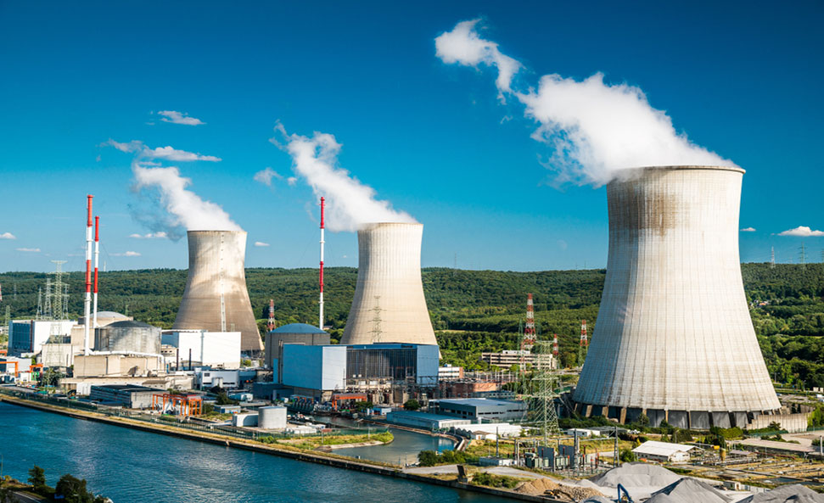

Summary Page:

Through our research and visualizations, we found 3 key insights as to what countries have had the most nuclear power growth, what countries are leading in CO2 emissions as well as the efficiency of nuclear plants compared to other types of power generation. Firstly, through our analysis of what countries have seen the most percent change in nuclear power generation per year, we found that Russia and Brazil have been leading in their adoption of nuclear power. However, a more important insight is seen by looking at the countries with lower percent changes. **USA, China, and India, which are some of the world’s largest countries and are fairly advanced are growing at a much slower rate** at pace along with countries that are still working on their power generation networks such as Pakistan and Mexico. Coupled with our **second key insight of how China, US, and India are leaders in CO2 emissions and largely overshadow many other countries in total emissions** (They make up more than half of the world’s total emissions!)

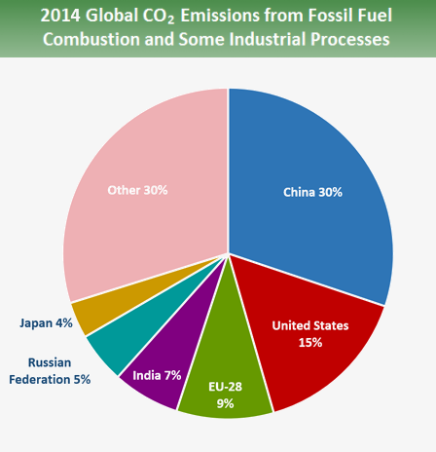

(<https://www.epa.gov/ghgemissions/global-greenhouse-gas-emissions-data>)

Lastly, a very important insight we found is that **nuclear power is much more efficient compared to other forms of power generation (coal, gas, renewables such as solar, hydro, etc.)**. By aggregating power plant efficiency/capacity data from power plants around the world we found that in terms of Capacity in MW, Nuclear Power plants can reach up to 2000+ MW, the highest among the different capacities for each type of power generation plant. This is also about 1000 MW more than coal power plants.

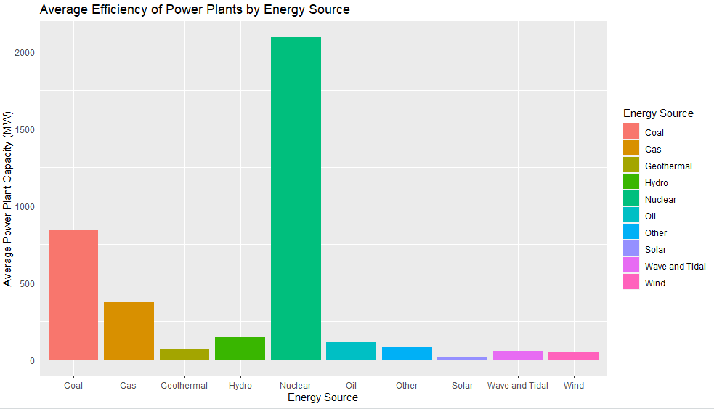

The implications of this data are extremely important. What it indicates is that not only do we need an adoption of a nuclear power plant network to sustainably produce power, we also need coordination and cooperation amongst countries in order to achieve that network. As The largest populated countries are producing most of the emissions, there needs to be international reform and accountability measures to ensure that those who have the largest negative impacts on the planet are working towards sustainable energy practices. As was seen in our analysis, nuclear power is more than efficient enough and produces no emissions that would speed up global warming. And considering that the claim that they “are extremely expensive and long to set up and maintain”, mostly the same could be said for building coal and gas power plants. What is necessary to understand is we incur a greater cost when we as a society let these gas and coal power plants be built, and we would be better off in the long-term by setting up safe and well-maintained nuclear power plants.

5.0 **Findings**.  New section.  Give answers to each of your research questions (400 words)

We asked the following questions in hopes of gaining a better understanding of the viability of nuclear energy as an effective deterrent to climate change.

1. **How prevalent is nuclear energy in the world right now?** Question 1’s goal is to inform the rest of our analysis by creating the necessary context about the world’s current nuclear energy production. In analyzing our data set, we chose to graph the highest percent change of nuclear power for many different countries over a time frame of ~60 years. What we found was that Brazil and Russia had had the most growth in creating more energy from their nuclear power plants. What was interesting was that even though Russia and Brazil did have high growth, countries that produce large amounts of CO2, such as China, India, and the US had relatively low growth. We found many other countries to also have low growth, but they also don’t have much CO2 emissions, so their nuclear energy produced isn’t as necessary.
2. **Where is the most CO2 emission happening?**  Question 2’s goal: In order to be able to effectively undermine the effects of global warming by building nuclear power plants that have zero CO2 emissions, it is necessary to understand which countries have the largest CO2 emissions into the atmosphere. By plotting CO2 emissions of highly populated countries over time, we found that China, India, and Russia are the largest emitters of CO2. This is especially important as it allows us to know where the most effective locations would be to curb climate change as rapidly as possible. By decreasing the CO2 emissions of the worlds leading emitters, we can bring the amount of greenhouse gases in the atmosphere while using an efficient power source.
3. **How does nuclear energy compare to other forms of alternative energy?** Question 4’s goal is to determine if other forms of alternative energy (solar, wind, etc…) are more or less viable than nuclear energy. One way we will answer this is by comparing the energy production of each form of power plant. Lastly, we used a data set which contained thousands of power plants located around the world. We aggregated each type of power plant and their respective power capacity. We found that the average nuclear powerplant dominates all other power plants with a 2000 MW capacity compared to the average capacity of coal power plants at about ~800 MW. Considering the fact that nuclear power plants don’t have any greenhouse gas emissions, this provides a huge advantage to the typical power production plants we have today whether they are renewable or non-renewable.